Optimize:
This means that Camunda Optimize adds extra process-insights and workflow-specific analytics that normal BI tools (like Power BI, Tableau, Qlik, etc.) cannot provide on their own.
Traditional BI tools show data, but they don’t understand process execution, workflow events, or step-by-step bottlenecks.
Optimize adds that missing layer.
Example Scenario
Traditional BI Tool (e.g., Power BI):
Power BI can show:
- How many loan applications were processed
- How many were approved/rejected
- Average processing time (based on raw data)
But it cannot tell you why delays happen, or which workflow step is slow.
With Camunda Optimize:
Optimize reads workflow data directly from Camunda (Zeebe + Operate).
So it can show:
- Which BPMN task is taking the longest
- Where the bottleneck is in your process
- How many process instances are stuck at a given step
- SLA violations tied to exact workflow steps
- Heat maps for process paths
- Compare versions of the same workflow
Sample Insight from Optimize:
Most delays happen in the Verify Documents user task, taking an average of 3.2 days, causing 40% SLA breaches.
A traditional BI tool cannot see this because it does not read process-engine events.
In short
Traditional BI = Shows business data
Optimize = Shows process flow intelligence, bottlenecks, root causes
Together, they give a full picture for better decisions.
------------------------------------------------------------------------------------------------------------------------------------

Camunda Console:
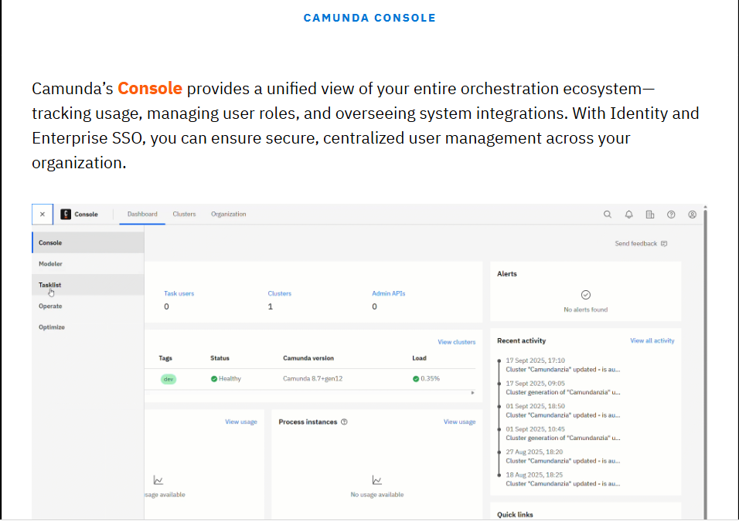
In Camunda 8, first model our process using Modeler, then deploy it to the Zeebe workflow engine for execution.
Zeebe can complete tasks directly or interact with job workers or connectors to advance the flow while reading and updating process variables.
Human tasks appear in Tasklist for users to work on, and process execution is monitored and troubleshot in Operate until the process reaches completion.
Finally, analyze process data in Optimize to obtain actionable insights.

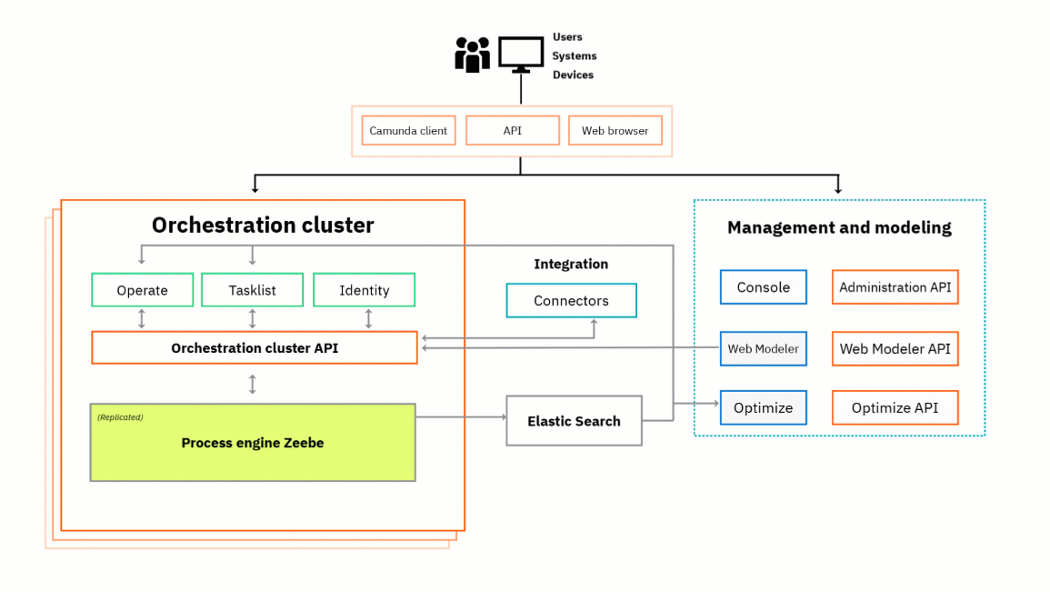
This diagram is a high-level view of a Camunda 8 (self-managed) deployment. It shows how users/clients interact with the orchestration cluster (the workflow engine and supporting services), how management & modelling tools sit alongside it, and where integration/connectors and observability fit.
Top / Clients
- Users / Systems / Devices — human users (browsers, Tasklist), other services, or automated clients that start/process workflows.
- Camunda client / API / Web browser — these are the entry points: a web app, REST/gRPC clients or the Console/Web Modeler/Tasklist interact with the platform.
Orchestration cluster (left, orange box)
- Process engine (Zeebe) — the core distributed workflow engine that executes BPMN processes. It is replicated and horizontally scalable (multiple broker nodes).
- Orchestration cluster API — gateway layer (gRPC/HTTP) that clients and management tools use to create/process instances and query state.
- Operate — runtime monitoring and troubleshooting UI: view active/process instances, inspect variables, incident handling, retries.
- Tasklist — UI for human tasks (user tasks) where humans claim/complete tasks.
- Identity — authentication/authorization service (users, groups, roles).
- Connectors (Integration) — runtime components that allow calling external systems (databases, email, cloud services, etc.). They run alongside the orchestration cluster or as part of the connector’s runtime.
Supporting storage & indexing
- Elasticsearch — used by Operate and Optimize to index process-instance data, events, logs and to support queries and analytics. Zeebe persists event logs (raft/log storage) and Operate uses ES for fast searching & analytics.
Management & Modeling (right, blue dashed box)
- Console / Web Modeler / Optimize — management and modeling UIs and services:
- Web Modeler: design BPMN models and deploy them to the Orchestration cluster.
- Console (or Admin UI): cluster administration, deployment status.
- Optimize: analytics/SLA dashboards, process mining and KPI reports.
- Each of these has associated APIs (Administration API, Web Modeler API, Optimize API) used to integrate CI/CD or automation.

Real-time example — Loan Origination (detailed flow)
Imagine a bank implementing an automated loan origination process with Camunda 8. The process involves automatic checks (credit score, fraud), human decisions (manual underwriting), external systems (CRM, credit bureau, email), SLA monitoring, and analytics.
1) Design & Deploy
- A business analyst builds the BPMN model in Web Modeler (applicant submission → eligibility check → credit check → underwriting decision → disbursement).
- The model is deployed to the Orchestration cluster via the Web Modeler API.
2) Customer submits application
- A customer fills a loan form on the bank’s web portal (Web browser).
- The portal calls the Cluster API (or a backend microservice) to create a process instance with application variables (applicantId, amount, documents).
- Zeebe records the new instance and schedules jobs for the first automated tasks.
3) Automated tasks (microservices & connectors)
- Eligibility Check: an external microservice (job worker) subscribes to a Zeebe job type like eligibility-check. Zeebe offers a job; the worker fetches it via the cluster API, performs checks against the bank’s rules engine, and completes the job with results (eligible: true/false).
- Credit Bureau Call: A Connector or a microservice calls the credit bureau API, receives a score → completes the Zeebe job with score variable.
- All interactions are asynchronous job-worker patterns: Zeebe issues jobs, workers poll/activate, do work, respond.
4) Human task (underwriting)
- If the automated checks require review, the process reaches a user task.
- A task appears in Tasklist for underwriters. Identity service enforces permissions.
- The underwriter reviews docs, asks for clarifications, and completes the task. Completing triggers the next workflow step in Zeebe.
5) Failures & retries
- If a connector call fails (credit bureau timeout), Zeebe creates an incident. Operate shows the incident for operators to investigate or trigger automated retries.
- Job retries and backoff are configured in the process model. Operators can re-deploy tasks or re-trigger.
6) Notifications & downstream systems
- When loan is approved, connectors send an email to the customer, update a CRM record, and call the core banking system to create the disbursement entry.
- Connectors (or external task workers) handle these integrations reliably (transactions, idempotency).
7) Monitoring, SLAs & analytics
- Operate provides live trace: see each process instance, its variables, active tasks, timeline, and incidents — useful for debugging or replaying misbehaving flows.
- Optimize aggregates data for KPIs: average credit-check time, SLA violations (e.g., underwriting must complete within 24 hours), conversion rates. Optimize reads indexed data from Elasticsearch.
8) Audit & search
- Events/variables needed for search/analytics are indexed in Elasticsearch so Operate/Optimize can query them quickly.
- Full audit trails are available: who approved, timestamps, variable values — required for compliance.

How components interact (sequence summary)
- Web app/API → deploy/start process via Cluster API.
- Zeebe schedules jobs and persists events.
- Job workers / Connectors poll/activate jobs → call external systems → complete jobs.
- User tasks surfaced in Tasklist, completed by humans (Identity enforces auth).
- Operate monitors runtime state & incidents; Elasticsearch stores indexed event data.
- Optimize consumes indexed data for reporting and SLA monitoring.
- Web Modeler / Console handle modeling, deployments, and admin actions.

Operational considerations & best practices

- Scalability: Zeebe brokers scale horizontally. Use multiple job worker instances for heavy connectors.
- Resilience: Design idempotent connectors; use retries and dead-letter patterns. Handle incidents in Operate.
- Security: Integrate Identity (OAuth/OIDC) for Tasklist and management tools; secure cluster API endpoints.
- Observability: Ship logs/metrics (Prometheus/Grafana) and use Operate + Elasticsearch for tracing and root-cause analysis.
- Data governance: Avoid storing sensitive PII directly in process variables if not necessary; mask/encrypt sensitive fields.
- Deployment: CI/CD should deploy BPMN models and microservices; use Web Modeler/Administration API for automated deployments.

Quick one-line summary
This architecture separates execution (Zeebe + cluster API + workers) from human interaction and monitoring (Tasklist & Operate) and modeling/management (Web Modeler, Console), while Elasticsearch provides fast indexing for search and analytics — enabling scalable, observable, and resilient business process automation across automated services and human tasks.
If you'd like, I can map the same flow to your specific domain (e.g., the banking Atumverse or Camunda connectors you were building), and produce a sequence diagram or a sample BPMN snippet showing job types and variables.

